Project Execution and Tracking

1. Project Execution Overview
The DRL Tracker project is executed through collaborative planning, task assignment, progress monitoring, and regular team communication. The team follows the project schedule and assignment milestones to organize its work and coordinate the development of the system.
The team uses Facebook Group as the primary communication channel, Google Docs for collaborative document preparation, GitHub for source code management and storing completed project documents, and Jira for task management and progress tracking. These tools support different aspects of the workflow, from initial task discussions to recording assignments and monitoring implementation progress.
As the project progresses, the team reviews its current status, identifies outstanding tasks, discusses issues, and adjusts its plans when necessary.

2. Tool Setup
The team uses the following tools to support project execution and tracking.
Tool | Purpose and Usage
Jira | Records project tasks, assignees, deadlines, descriptions, and task statuses. It is used to organize work and monitor progress throughout the project.
GitHub | Manages the source code repository and stores completed project documents. It provides a shared location for team members to access project materials.
Google Docs | Supports collaborative writing and editing of project documents before they are finalized.
Facebook Group | Serves as the primary communication channel for discussing project activities, distributing tasks, clarifying requirements, and coordinating team members.
The team combines these tools to maintain communication and keep project activities organized. Task assignments are initially discussed in Facebook Group and subsequently recorded in Jira for structured tracking. Documents are collaboratively prepared in Google Docs and uploaded to GitHub when completed.
Evidence to include:
- Figure 1. Jira project task list.
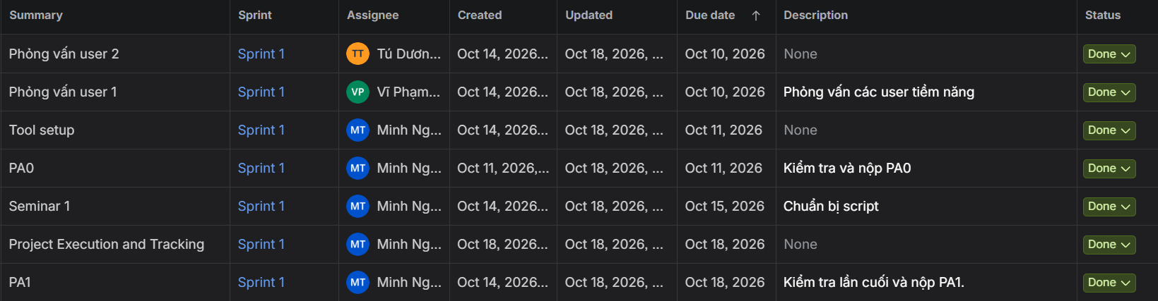
- Figure 2. GitHub project repository.
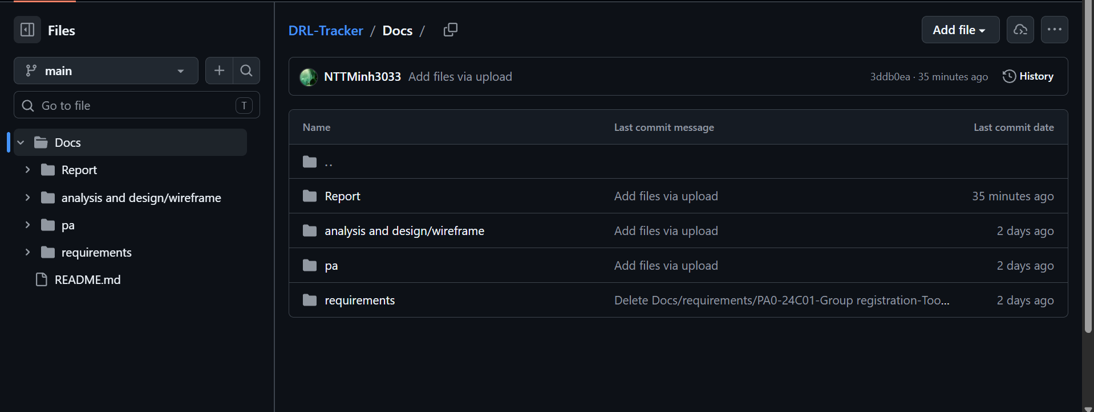
- Figure 3. Collaborative document preparation in Google Docs.
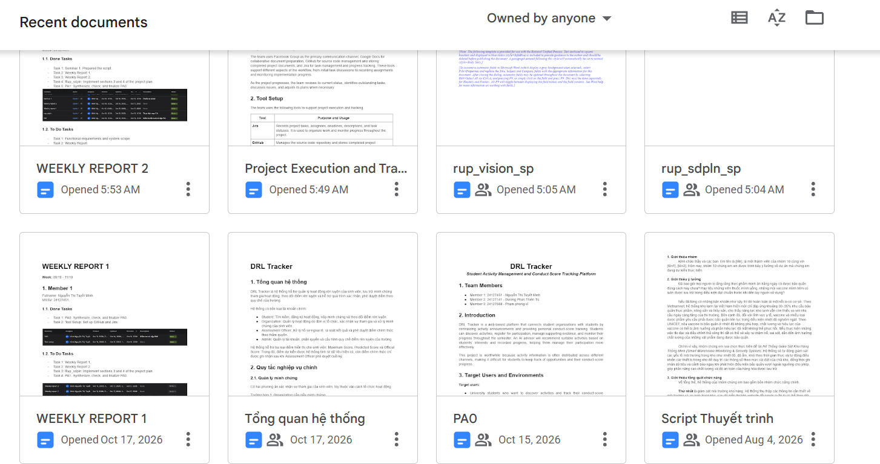
- Figure 4. Team coordination and initial task assignment in Facebook Group.
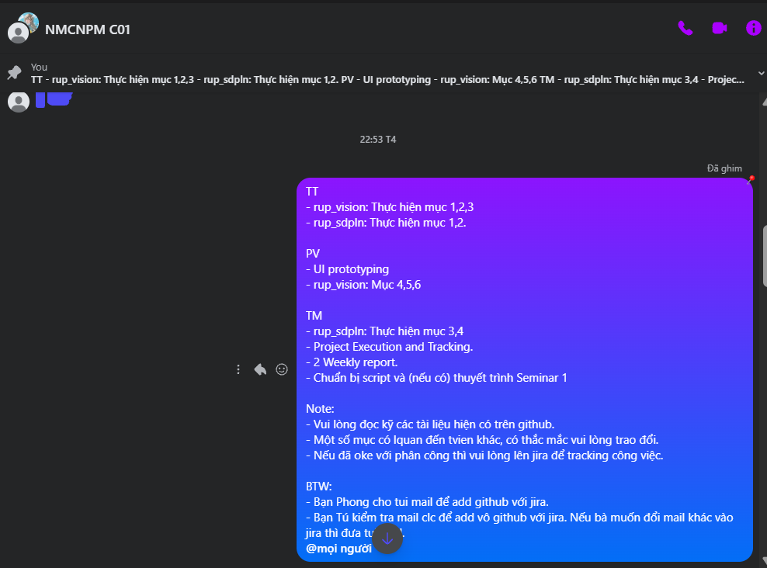

3. Planning and Task Allocation
The team organizes its work according to the project schedule, assignment requirements, and sprint objectives. The Team Leader coordinates activities and initially distributes tasks through Facebook Group discussions. Members clarify the requirements and discuss their responsibilities before the tasks are recorded in Jira.
Jira is used to document the task name, description, assignee, creation date, due date, and current status where applicable. This allows the team to identify task ownership, review upcoming deadlines, and follow the progress of assigned work.
Task allocation is coordinated according to the responsibilities of each member while ensuring that all members participate in the development process. Assignments may be adjusted when requirements change, tasks depend on one another, or the team identifies a need to redistribute work.
The current sprint's recorded tasks represent the work that has been organized in Jira. Tasks for subsequent sprints are treated as preliminary plans until their scope, ownership, and deadlines have been reviewed and confirmed by the team.
Evidence to include:
- Figure 5. Preliminary plans in Jira.
